Victorian Disability Worker Commission and Disability Worker Registration Board of Victoria
corporate plan 2022–2024

Acknowledgement of Country
We proudly acknowledge Victoria’s First Nations peoples and their ongoing strength in practising the world’s oldest living culture. We acknowledge the Traditional Owners of the lands and waters on which we live and work and pay our respect to their Elders past and present. We acknowledge the ongoing role of the Aboriginal community in supporting those with disability.

Accessibility statement
If you would like an alternative format, please email the Commission <info@vdwc.vic.gov.au>.
This document is also available in Word and PDF formats on the Commission’s website <https://vdwc.vic.gov.au>.
The Commission and Board are statutory entities of the State Government of Victoria created under the Disability Service Safeguards Act 2018.
© State of Victoria (Victorian Disability Worker Commission and Disability Worker Registration Board of Victoria) 2022
The Victorian Disability Worker Commission and Disability Worker Registration Board of Victoria corporate plan 2022–2024 is licenced under a Creative Commons Attribution 4.0 licence.
You are free to re-use the work under that licence, on the condition that you credit the State of Victoria (Victorian Disability Worker Commission and Disability Worker Registration Board of Victoria) as author, indicate if changes were made and comply with other licence terms. The licence does not apply to any images, photographs or branding, including the Victorian Government logo, Victorian Disability Worker Commission logo, the Disability Worker Registration Board of Victoria logo and the logos used to certify registration as a registered disability worker.
Copyright queries may be directed to info@vdwc.vic.gov.au
ISSN 2653-6161 – Online (pdf/word)
Published October 2022
Victorian Disability Worker Commission
Level 20, 570 Bourke Street
Melbourne Victoria 3000
Phone: 1800 497 132
Email: info@vdwc.vic.gov.au
Web: vdwc.vic.gov.au

Contents
Message from Commissioner and Board Chairperson 4
About us 5
Our purpose 5
What we currently do 5
Our operating environment 6
Our values 8
Diversity and inclusion 8
Independent and fair 8
Fearless and accountable 8
Trust and respect 8
Empathy and dignity 8
Our Scheme strategic plan 2022 to 2024 9
Our maturity model 9
Scheme strategic plan 2022 to 2024 9
Our focus for 2022 to 2023 11
Tracking our performance 14
Monthly review of key performance indicators and measures 14
Performance reporting against our business plan 14
Yearly review of our impact 14
Approach to risk management 16
Appendix 1: Image descriptions 17

Message from Commissioner and Board Chairperson
We are pleased to present this corporate plan, which sets out how the Board and the Commission will implement our joint strategic plan in 2022-2023. The corporate plan builds on our experience and early learnings of implementing the Disability Worker Regulation Scheme.
It is the third year of regulatory activity for the Commission and the second year of taking registrations for the Board. We are therefore aware of many of the challenges and opportunities in front of us as we work to achieve our strategic outcomes.
Whilst we continue the major and essential parts of the Board and Commission’s work of registering workers, taking complaints and notifications, this plan highlights the activity to achieve our priorities over the next year. Commensurate with the stage of development of the Board and Commission, our strategic activities are focused on educating stakeholders, building community understanding of our roles, and developing our capacity to achieve a high quality and safe disability workforce in Victoria.
Our key priorities for this financial year are to respond efficiently to the growing number of complaints and notifications regarding unsafe or poor-quality disability services. In identifying our key strategic actions and projects for the next financial year we have given urgency to those that have the biggest impact for our organisation as well as benefits to our stakeholders.
We are aware of the difficulties that the COVID-19 pandemic has placed on our sector and its range of implications. We are committed to work closely with our stakeholders in the implementation of the scheme so that together we can make a realistic difference to people living with disability.
The corporate plan does not provide detail on the 2023-2024 actions as the Commission has only received budget allocation until June 2023. We have limited our annual planning to known resources whilst we operate on the basis that for the following year we will receive a similar budget to this year, plus funding for some specific areas of work. In a way it is an ambitious corporate plan; however it is one we believe we can achieve.

Dan Stubbs
Commissioner
Victorian Disability Worker Commission
Melanie Eagle
Chairperson
Disability Worker Registration Board of Victoria

About us

Our purpose
We regulate all workers providing disability services in Victoria, regardless of how they’re funded, setting standards for registration and training, resolving complaints and prohibiting unsafe workers.

What we currently do
This is the shared corporate plan for the Victorian Disability Worker Commission (Commission) and the Disability Worker Registration Board of Victoria (Board).
We manage the Disability Worker Regulation Scheme (the Scheme) by:
- regulating registered disability workers through a voluntary registration scheme
- developing professional registration standards to promote professionalisation of the disability workforce
- regulating the conduct of all disability workers operating in Victoria via a Code of Conduct
- investigating and responding to complaints and notifications about disability workers
- sharing appropriate information with regulators about disability workers to support quality and safety in the disability workforce.
For a full list of Board and Commission functions please see the Disability Service Safeguards Act 2018 (DSS Act).
Figure 1 illustrates the interrelationships between the roles of the Commission, the Commissioner and the Board.
Figure 1: Interrelationships between the Commission, the Commissioner and the Board
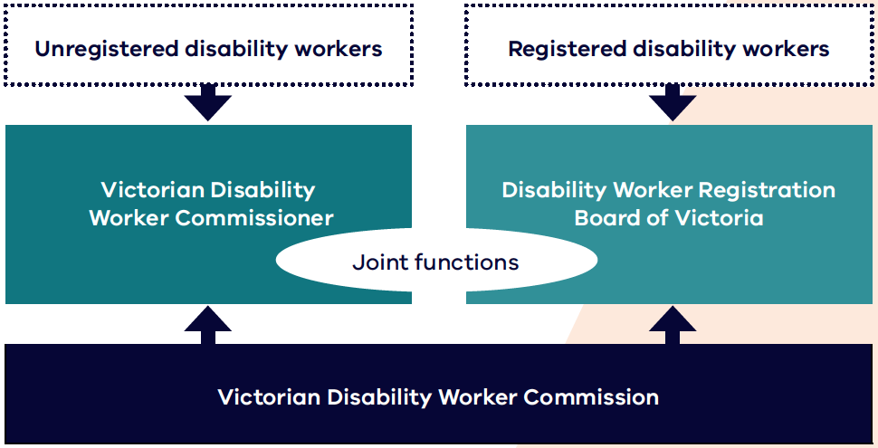

In August 2018 the Victorian Parliament passed the DSS Act to improve the quality and safety of disability care and service standards. The DSS Act set up the Scheme.
The Scheme covers all Victorian disability workers (registered and unregistered) and students training to be disability workers in Victoria. It started on 1 July 2020 and forms part of the Victorian Government’s zero tolerance approach to the abuse of people with disability.
The DSS Act:
- creates a voluntary registration scheme for disability workers
- provides a way to make a complaint or a notification about any disability worker in Victoria
- requires all unregistered disability workers comply with a Code of Conduct
- creates the Victorian Disability Worker Commission, the Victorian Disability Worker Commissioner and the Disability Worker Registration Board of Victoria as regulators of the Scheme.

Our operating environment
In Victoria, 17 per cent of people identify as having a disability. Thirty-two per cent of people with disability sometimes or always need help with self-care, mobility or communication.
In Victoria, just over 10 per cent of the 1.1 million Victorians with disability are eligible for a National Disability Insurance Scheme (NDIS) plan. This means that many Victorians receive support outside the NDIS framework.
The Scheme covers both NDIS and non-NDIS disability workers and protects people with disability, including those who are not NDIS participants. This represents the majority of Victorians with disability who use support services.
In Victoria, many bodies work together to support safe disability services. We work with other agencies and organisations, including other workforce regulators including:
- NDIS Quality and Safeguards Commission
- Australian Health Practitioner Regulation Agency (AHPRA)
- Health Complaints Commissioner
- Mental Health Complaints Commissioner
- Commission for Children and Young People
- Victorian Institute of Teaching
- Office of the Public Advocate
- Disability Services Commissioner.
In Victoria, we also work closely with the Department of Justice and Community Safety, which administers NDIS worker screening, and the Department of Families, Fairness and Housing.
Disability support work is complex. It needs a workforce with the skills and expertise to provide safe, quality supports.

More broadly, there are pressures on the supply of the workforce in the disability sector. Key factors impacting the size of the workforce include:
- competition for workers with other sectors including aged care and childcare
- casualisation of the workforce, which is female dominated
- relatively low pay rates.
A high turnover rate amongst casual disability workers has also added pressure to the disability workforce. The turnover rate has increased from 18 per cent in December 2020 to 22 per cent in June 2021.
During 2021 and 2022, the COVID-19 pandemic has continued to have unprecedented public health, social and economic implications for the community. These effects have been acute for people with disability and the disability workforce.
From an operational perspective, the COVID-19 pandemic has meant that the operations of the Commission and Board have mainly been conducted online. Staff did not begin returning to offices and workplaces until early in 2022.
In this context, as new organisations, the Commission and Board have focused our work on building awareness of the Scheme with stakeholders. Our regulatory approach has reflected this aim. We actively provide a ‘no wrong door’ approach to support people with disability and help resolve their queries, including by referring matters to appropriate agencies.

Our values
Our values inform what we do and how we do it.

Diversity and inclusion
- We have inclusive recruitment and employment practices that foster diversity in our workforce.
- We ensure that diverse communities see themselves in who we are and what we do.
- We are committed to being an accessible workplace and an accessible regulator for our diverse stakeholders.

Independent and fair
- We treat everyone with respect, listening to all parties involved.
- We do what we say we will do and take proportionate action.
- The community sees our processes and decisions as independent and transparent.

Fearless and accountable
- We use our powers to hold others accountable for their actions.
- We are responsible for our actions and are open to scrutiny and feedback.
- We continually evaluate and improve our operations.

Trust and respect
- We are respectful and professional with colleagues and the community.
- We foster trust by assessing matters impartially.
- We have confidence in and are respectful of each other’s skills and capabilities.

Empathy and dignity
- We take a person-centred approach to everything we do.
- We ask people what they need from us and how we can work with them.
- We are responsive and flexible to support the diverse communities and people we serve.

Our Scheme strategic plan 2022 to 2024

Our maturity model
As a new organisation we have to be conscious that our journey recently began, and that maturation requires time and effort. With this in mind we have designed an ambitious four-phase model to ensure that by 2024 we can operate at the same level of any established organisation.
Figure 2: Maturity model
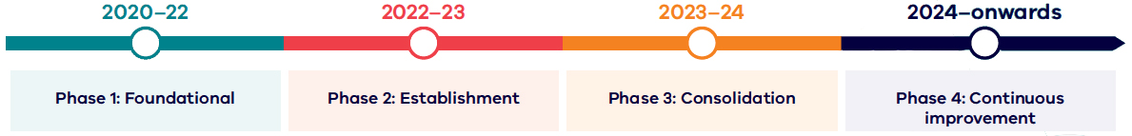
Table 1: Phases of the maturity model
Year | Phase
2020 to 2022 | Phase 1: Foundational  The focus of this first phase is to prepare and develop foundational pieces that allow for initial operation.
2022 to 2023 | Phase 2: Establishment  At this phase, the focus is to engage with our external stakeholders to collect evidence to improve our operations.
2023 to 2024 | Phase 3: Consolidation  The focus of this phase is to consolidate our way of operating and assess how far we have come in implementing the scheme.
2024 onwards | Phase 4: Continuous improvement  At this phase, our operating model has been consolidated and ongoing changes are made based on key performance indicators.

Scheme strategic plan 2022 to 2024
In 2022, the Commission and Board worked together to create a Scheme strategic plan. The plan has five pillars in total:
- the first four representing where the Scheme needs to concentrate its efforts to support people with disability
- a fifth pillar describing the crucial support required to enable the functions and delivery of pillars 1 to 4, acknowledging the relationships between the Commissioner, the Board and the Commission.

Figure 3: Our strategic plan 2022 to 2024 on a page
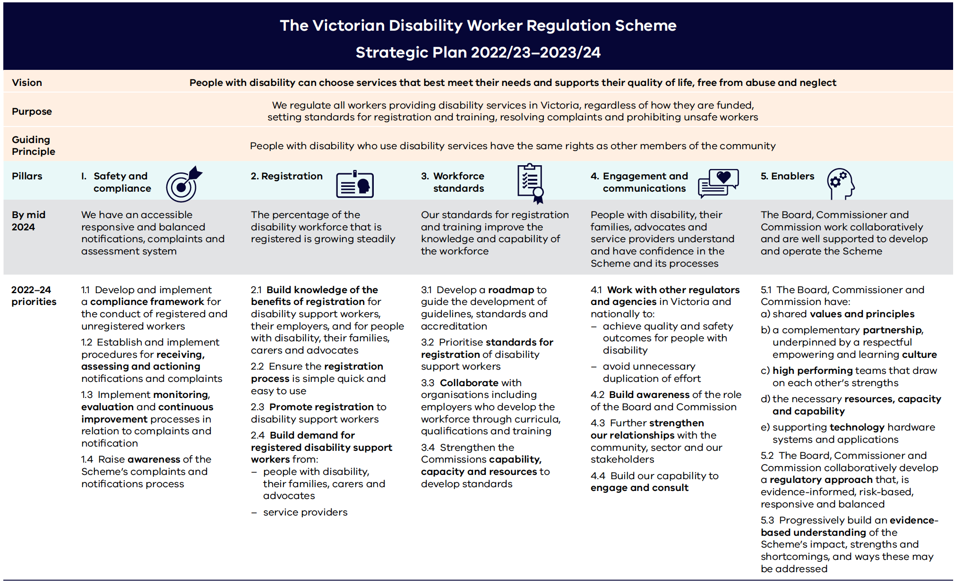

Our focus for 2022 to 2023
A significant proportion of our resources dedicated to delivering the Scheme are allocated to core regulatory and enabling functions, as shown in Table 2.
At this stage in our maturity journey, many of these functions correspond to completing foundational work.
Our key priorities for this financial year are to respond efficiently to the growing number of complaints and notifications regarding unsafe or poor-quality disability services. This reflects the maturity of the Scheme and the increasing number of people who use disability services as well as a growth in the number of registered disability support workers and practitioners.
Table 3 shows our key actions and projects for 2022-2023. To this end we are building our capabilities, profile and recognition in the disability sector.
Much of our actions and deliverables this year are therefore also reliant on promoting recognition and understanding of our work in the community.
This important work will help us to increase our profile and build community confidence in the work of the Commission and Board.
At the same time, we plan to undertake analysis and consultation to prepare for the development and implementation of new important standards to promote the quality and recognition of disability workers registered under the Scheme.
Table 2: Core regulatory and enabling functions
Pillar | Function
Safety and compliance | - Complaint handling and responses  - Investigations  - Prohibition orders  - Working with other regulators
Registration | - Registration assessment  - Continuous improvement to application and renewal processes  - Customer support  - Publishing the register of registered disability workers
Workforce standards | - Policy directions and guidance  - Standards, guidelines development and fees  - Accreditation processes
Engagement and communication | - Stakeholder engagement  - Public information and education campaigns  - Media presence
Enablers | - Corporate compliance  - Internal audit  - Board Secretariat  - Strategic and operational policy  - Recruitment management  - Health and safety  - Finance  - Diversity and inclusion  - Legal advice  - Strategic planning and risk management  - IT development and support  - Data management and analytics  - Monitoring and evaluation  - Research  - Delegations and authorisations

Table 3: Key strategic actions and projects for 2022-2023
The core regulatory and enabling functions underpin and support each of the five pillars.
Pillar | 2024 outcome | Key strategic action or project
1. Safety and compliance | We have an accessible responsive and balanced notifications, complaints and assessment system | - Develop a compliance framework (including policy and regulatory approach) (Priority 1.1)  - Develop a stakeholder feedback survey (Priority 1.3)
2. Registration | The percentage of the disability workforce that is registered is growing steadily | - Establish a fee policy (Priority 2.3)  - Develop a new model of assessment written as guidance (Priority 2.2)  - Revise application and renewal process (Priority 2.2)  - Undertake a criminal history check reform project (Priority 2.2)
3. Workforce standards | Our standards for registration and training improve the knowledge and capability of the workforce | - Develop a roadmap for registration standards (Priority 3.1)  - Prioritise registration standards (Priority 3.2)
4. Engagement and communication | People with disability, their families, advocates and service providers understand and have confidence in the Scheme and its processes | - Develop a communications and engagement plan (Priority 1.4, 2.1, 2.3, 2.4, 4.2, 4.3)  - Strengthen collaboration and engagement with other regulators and agencies (Priority 4.1)
5. Enablers | The Board, Commissioner and Commission work collaboratively and are well supported to develop and operate the Scheme | - Develop a reporting infrastructure (Priority 5.3)  - Develop a stakeholder engagement plan (Priority 5.3)

Tracking our performance
We have developed a monitoring, evaluation and learning (MEL) framework to ensure the Commission and the Board have the tools needed to make well-informed, evidence- based decisions. We have established three ways of looking at our performance over the year.

Monthly review of key performance indicators and measures
Our two key regulatory functions are the focus of Pillar 1: Safety and compliance and Pillar 2: Registration.
These are supported by engagement and communications activities in Pillar 4.
On a monthly basis the Commission monitors a range of key performance indicators and measures across these pillars and uses them to inform our day-to-day operations.

Performance reporting against our business plan
The Commission monitors progress against our key actions and projects monthly and updates the Board quarterly on this progress.

Yearly review of our impact
Central to accountability is our MEL framework. The framework contains:
- the desired outcomes of the Scheme
- an indication of how we are going to achieve these
- realistic indicators and measures.
Annual reviews have been planned, describing our progress towards the Scheme outcomes and outputs.

Table 4: Example of performance measures
Measure | Pillar
Number of notifications received | Pillar 1: Safety and compliance
Number of notifications closed | Pillar 1: Safety and compliance
Number of complaints received | Pillar 1: Safety and compliance
Number of investigations commenced | Pillar 1: Safety and compliance
Number of workers counselled (See note) | Pillar 1: Safety and compliance
Number of applications for registration | Pillar 2: Registration
Number of registrations granted | Pillar 2: Registration
Number of stakeholders engaged through meetings | Pillar 4: Engagement and communication
Number of documents downloaded from website | Pillar 4: Engagement and communication
Note: Counselling has been the predominate compliance and enforcement tool in the establishment phase of the Scheme to align with the educative approach to compliance and ensure that disability workers understand their obligations. As the Scheme becomes more mature and expectations and understanding of regulatory obligations improve, a proportionate response is likely to include a wider range of compliance and enforcement tools.

Approach to risk management
We have taken a Scheme view of our risks (encompassing the Commission and Board). The significance of these risks will vary over time.
Broadly, these risks relate to:
- protecting people with disabilities and their wellbeing through promoting the Scheme and taking appropriate compliance and enforcement action regarding the quality and safety of services received
- promoting the Scheme and the professionalisation of the disability workforce to enhance the quality and safety of services they provide
- the effective operation of the Scheme, appropriate resourcing and well-supported Commission and Board to deliver outcomes
Operational risks are actively managed through ongoing internal discussions and an internal audit plan that actively addresses the way both the Board and Commission operate to manage the Scheme. When required, these risks are escalated in various ways, for example to the Audit and Risk Committee or with the Commissioner and Board Chair directly.

Appendix 1: Image descriptions

Figure 3: Our strategic plan 2022 to 2024 on a page
Figure 3 summarises the Victorian disability worker regulation scheme strategic plan for 2022 to 2024.
It states the Commission and Board’s vision, purpose and guiding principle.
For each pillar, it also summarises the:
- outcome to be achieved by mid-2024
- priorities for 2022 to 2024.

The Victorian Disability Worker Regulation Scheme strategic plan 2022-2023 to 2023-2024

Vision
People with disability can choose services that best meet their needs and supports their quality of life, free from abuse and neglect.

Purpose
We regulate all workers providing disability services in Victoria, regardless of how they are funded, setting standards for registration and training, resolving complaints and prohibiting unsafe workers.

Guiding principle
People with disability who use disability services have the same rights as other members of the community.

Pillar 1: Safety and compliance
Outcome by mid-2024:
- We have an accessible responsive and balanced notifications, complaints and assessment system.
Priorities for 2022 to 2024:
- 1.1 Develop and implement a compliance framework for the conduct of registered and unregistered workers.
- 1.2 Establish and implement procedures for receiving, assessing and actioning notifications and complaints.
- 1.3 Implement monitoring, evaluation and continuous improvement processes in relation to complaints and notification.
- 1.4 Raise awareness of the Scheme's complaints and notifications process.

Pillar 2: Registration
Outcome by mid-2024:
- The percentage of the disability workforce that is registered is growing steadily.
Priorities for 2022 to 2024:
- 2.1 Build knowledge of the benefits of registration for disability support workers, their employers, and for people with disability, their families, carers and advocates.
- 2.2 Ensure the registration process is simple quick and easy to use.
- 2.3 Promote registration to disability support workers.
- 2.4 Build demand for registered disability support workers from:
  - people with disability, their families, carers and advocates
  - service providers.

Pillar 3: Workforce standards
Outcome by mid-2024:
- Our standards for registration and training improve the knowledge and capability of the workforce.
Priorities for 2022 to 2024:
- 3.1 Develop a roadmap to guide the development of guidelines, standards and accreditation.
- 3.2 Prioritise standards for registration of disability support workers.
- 3.3 Collaborate with organisations including employers who develop the workforce through curricula, qualifications and training.
- 3.4 Strengthen the Commission’s capability, capacity and resources to develop standards.

Pillar 4: Engagement and communication
Outcome by mid-2024:
- People with disability, their families, advocates and service providers understand and have confidence in the Scheme and its processes.
Priorities for 2022 to 2024:
- 4.1 Work with other regulators and agencies in Victoria and nationally to:
  - achieve quality and safety outcomes for people with disability
  - avoid unnecessary duplication of effort.
- 4.2 Build awareness of the role of the Board and Commission.
- 4.3 Further strengthen our relationships with the community, sector and our stakeholders.
- 4.4 Build our capability to engage and consult.

Pillar 5: Enablers
Outcome by mid-2024:
- The Board, Commissioner and Commission work collaboratively and are well supported to develop and operate the Scheme.
Priorities for 2022 to 2024:
- 5.1 The Board, Commissioner and Commission have:
  - shared values and principles
  - a complementary partnership, underpinned by a respectful empowering and learning culture
  - high-performing teams that draw on each other's strengths
  - the necessary resources, capacity and capability
  - supporting technology hardware systems and applications.
- 5.2 The Board, Commissioner and Commission collaboratively develop a regulatory approach that, is evidence-informed, risk-based, responsive and balanced.
- 5.3 Progressively build an evidence-based understanding of the Scheme's impact, strengths and shortcomings, and ways these may be addressed.
Return to Scheme strategic plan 2022 to 2024.

Australian Bureau of Statistics 2018, Disability, ageing and carers, Australia: summary of findings, Australian Government, Canberra, cited in Department of Families, Fairness and Housing 2022, Inclusive Victoria: state disability plan 2022–2026, State of Victoria, Melbourne, p 12.
Australian Institute of Health and Welfare 2020, People with disability Australia, Australian Government, Canberra.
Australian Bureau of Statistics 2018, Disability, ageing and carers, Australia: summary of findings, Australian Government, Canberra
National Disability Services Victoria, Victorian disability workforce environmental scan for 2022, February 2022, p 6.

